Assignment1 for MAST90058

Name: Mu Tong

Student Number: 1004452

Problem 1:

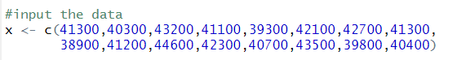

1. Show the basic summary statistics and produce a box plot.

R script:

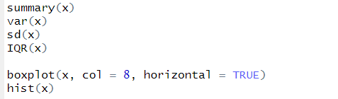

Output:

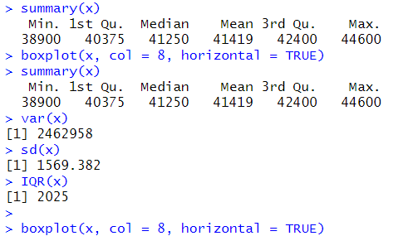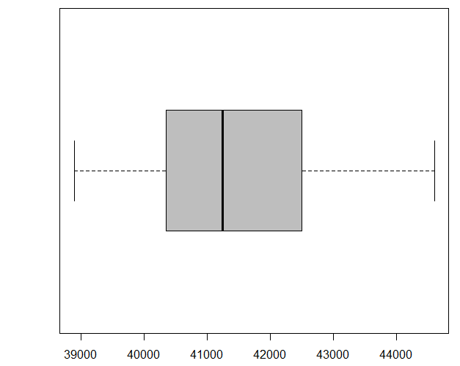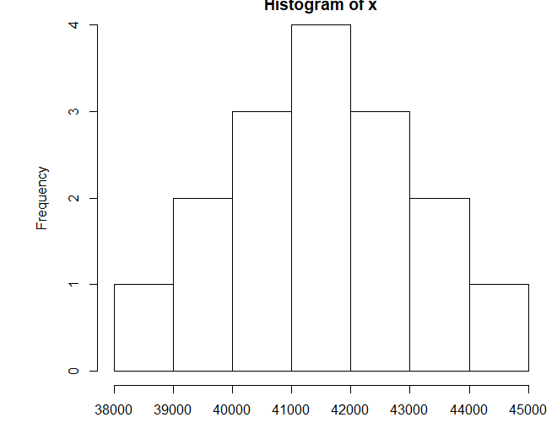

We can find that it is a roughly symmetric shape according to the histogram, and the center of this distribution is the mean (41419), and the spread of this distribution is the standard deviation (1569.382).

b)

R script:

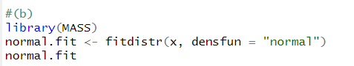

Output:

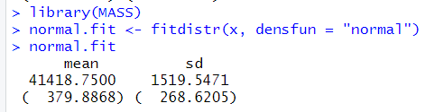

We can find that MLE for mean is 4148.7500 and MLE for standard deviation is 1519.5471.

c) R script:

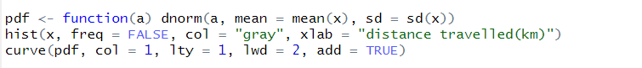

Output:

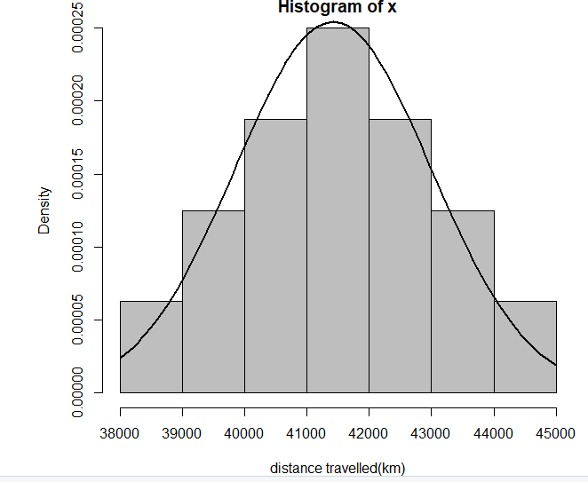

d)

R script:



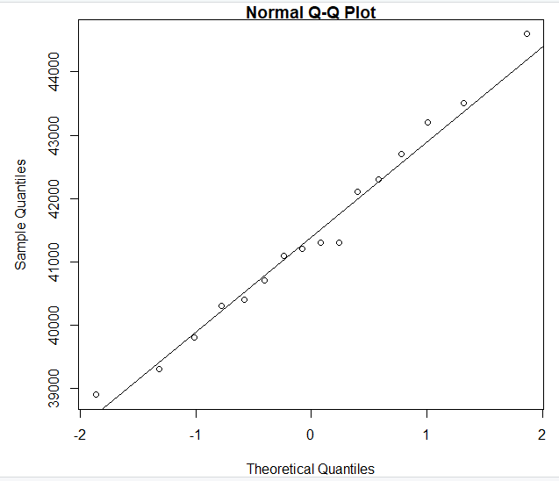

We can find that the sample data roughly match the theoretical model.

4.(c)

(i)

R script:

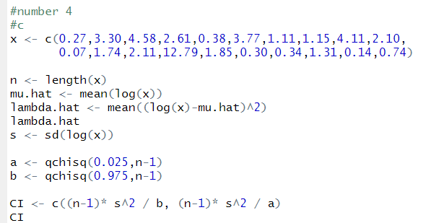

Output:



(ii)

R script:

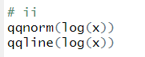

Output:

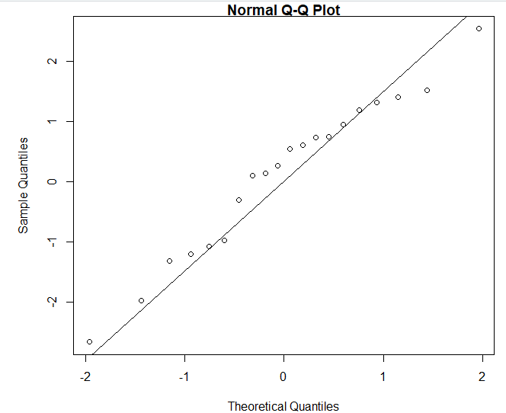

We can find that the model is roughly appropriate for these data.